DECLARATION
We, HARSHITHA GL, HEMAVATHI B, NITISH KUMAR and SAQIB MEHMOOD BHAT hereby declare that, this project work entitled “GESTURE CONTROLLED ROBOT USING SIXTH SENSE TECHNOLOGY” is an original and bonafide work carried out by us at SSIT Tumakuru, in partial fulfilment of BACHELOR OF ENGINEERING in Electronics and Communication Engineering.
We also declare that, to the best of our knowledge and belief, the work reported herein does not form part of any other thesis or dissertation on the basis of which a degree or award was conferred on an earlier occasion by any student.

Date:
Place:

HARSHITHA GL (15EC022)

HEMAVATHI B (15EC025)

NITISH KUMAR (15EC056)

SAQIB MEHMOOD BHAT (15EC079)

SRI SIDDHARTHA ACADEMY OF HIGHER EDUCATION
(Declared as Deemed to be University Under Section 3 of the UGC Act, 1956
Approved by AICTE, Accredited by NBA, NAAC with ‘A’ Grade)
AGALKOTE, TUMAKURU – 572107,
KARNATAKA

Project Report
On
“IMAGE PROCESSING BASED SELF DISPENSING RATION CARD SYSTEM TO AVOID MALPRACTICES”

Submitted by:
SUSHMA V M (14EC432)
SHARATH V (12EC084)
ANKIT KUMAR (12EC008)

Under the Guidance of
Mrs. MANJULA Y _{B.E., M.Tech., (Ph.D),}
Asst. Professor, Department of ECE,
S.S.I.T, Tumakuru.

Submitted in partial fulfillment of
BACHELOR OF ENGINEERING
IN
ELECTRONICS AND COMMUNICATION ENGINEERING

DEPARTMENT OF ELECTRONICS AND COMMUNICATION ENGG
SRI SIDDHARTHA INSTITUTE OF TECHNOLOGY
(A Constituent College of Sri Siddhartha Academy of Higher Education)
MARALUR, TUMAKURU -572105,
2016-2017

ACKNOWLEDGEMENT

The satisfaction and euphoria that accompany the successful completion of any task would be incomplete without mention of the people who made it possible and support had been a constant source of encouragement which crowned my efforts with success.

We would like to express our sincere thanks to our beloved Principal Dr. M.K.Veeraiah, S.S.I.T, Tumakuru, for providing us an opportunity to do this project.
Our special gratitude to Dr. M. Z. Kurian, Professor & Head, Department of Electronics and Communication, S.S.I.T, Tumakuru, for his guidance, constant encouragement and whole hearted support.

Our special gratitude to our project guide Mrs. Manjula Y, Asst. Professor, Department of Electronics and Communication, S.S.I.T, Tumakuru, for her guidance, constant encouragement and whole hearted support.

We would like to express our sincere thanks to all the staff members of Electronics and Communication Department, S.S.I.T, for their valuable support.

Last but not the least, we would express our gratitude to our family and friends those who have supported us directly or indirectly to do this project

Project Associates

SUSHMA V M (14EC432)
SHARATH V (12EC084)
ANKIT KUMAR (12EC008)

SRI SIDDHARTHA INSTITUTE OF TECHNOLOGY
(A Constituent College of Sri Siddhartha Academy of Higher Education, Tumakuru,
Approved by AICTE, Accredited by NBA, NAAC with ‘A’ Grade)
Maralur, Tumakuru – 572 105

DEPARTMENT OF ELETRONICS AND COMMUNICATION ENGINEERING

CERTIFICATE
This is to certify that the project entitled “Gesture controlled robot using Sixth Sense Technology” is a bonafide work carried out by Harshitha G L, Hemavathi B, Nitish Kumar and Saqib Mehmood Bhat in partial fulfillment of the award of the degree of Bachelor of Engineering in Electronics and Communication Engineering during the academic year of 2018-19.
It is certified that all of the corrections/suggestions indicated for the internal assessment have been incorporated in the report. The project report has been approved as it satisfies the academic requirements with respect to the project work prescribed for the award of the degree of Bachelor of Engineering in Electronics and Communication Engineering.

Signature of the Guide | Signature of the HOD | Signature of the Principal
Mrs. Manjula Y | Dr. M.Z. Kurian | Dr. M. K. Veeraiah
B.E., M.Tech., (Ph.D) | B.E., M.Tech., Ph.D., FIE., | M.Sc., M.Ed., Ph.D., LM-ISTE.,
Asst. Professor, Dept of ECE, | MISTE., MIEEE, | ISCA., AIMA,
SSIT, Tumakuru. | Professor & Head, Dept of ECE, SSIT, Tumakuru | Principal, SSIT,  Tumakuru

Submitted by:
HARSHITHA GL (15EC022)
HEMAVATHI B (15EC025)
NITISH KUMAR (15EC056)
SAQIB MEHMOOD BHAT (15EC079)

External Examiner (s)- Signature with date-

1.

2

ABSTRACT

The main aim of the project is to prevent malpractices and providing basic domestic commodities on subsidy to poor families in developing countries like India is an important aspect to meet fundamental requirements of people.

The existing public distribution system in Ration shops requires manual measurement of quantity and maintenance of record transactions. Many problems are encountered by the existing system.

The project titled Smart Ration Shop proposes an automatic method of distribution of commodities to authenticated card holders. Also, the details of transactions made are maintained in a database.

At the primary level RFID authentication is used and at the next level a family member is identified by his/her fingerprint template which makes the system more secure.

CONTENTS

Chapters Page No.

1. INTRODUCTION 01
1.1 Objective and Motivation 01
1.2 Problem Definition 02
1.3 Problem Solution 03
1.4 Methodologies 03
1.5 organization of the report 04
2. LITERATURE SURVEY 05
3. SYSTEM DESIGN AND DESCRIPTION 07
3.1 Hardware Tools 10
3.1.1 Card and reader 10
3.1.2 Identification using Finger print module 10
3.1.3 Microcontroller 10
3.1.4 Motors and Realay Circuit 17
3.1.5 GSM Unit 22
3.1.6 Hydraulic Valve 22
3.1.7 LCD and Keypad 22
4. SYSTEM HARDWARE DESCRIPTION 23
4.1 Radio Frequency Identifier(Rfid) Module 23
4.2 Microcontroller LPC2148 24
4.3 R303a Fingerprint Module 26
4.4 Global Systems for mobile communications (GSM)
Modem Module 27
4.5 DC Motor 29
4.6 Hydraulic valve 30
4.7 Relay Circuit 31
4.8 LCD and Keypad 31
5. SYSTEM SOFTWARE 33
5.1 Kiel vision 4 33
5.2 Philips LPC2000 ash utility V2.2.3 33

6. SYSTEM IMPLEMENTATION 34
6.1 Project Program Module 34
6.1.1 Card and Reader 34
6.1.2 Identification using Finger print module 35
6.1.3 Microcontroller 35
6.1.4 Motors and Relay circuit 35
6.1.5 GSM Unit 35
6.1.6 Hydraulic Valve 35
6.1.7 LCD and Keypad 35
6.1.8 RFID Module 36
6.1.9 Fingerprint Module 37
6.1.10 Flow Chart of the System 38
7. RESULT 41
7.1 Snapshot 41
7.2 Quantity Analysis 45
8. ADVANTAGES 46
9. APPLICATIONS 47
10. CONCLUSION 48
11. FUTURE ENHANCEMENT 49
REFERENCES 50

LIST OF FIGURES

Figures Page No.

Figure 1.1: Kerosene cans placed by cardholders in front of
the ration shop 02
Figure 2.1: A RFID Based Card 06
Figure 3. 1: Over All Block Diagram 07
Figure 3.2: pin configuration lpc2148 11
Figure 3. 3 : lpc2148 Block Diagram 13
Figure 3.4: Graphical Representation of the ARM Memory 16
Figure 3.5 Pin Diagram Secrete L239 Driver Motor 18
Figure 3.6: Circuit Diagram 20
Figure 4.1: RFID reader nsk edk - 125 –TTL 23
Figure 4.2: Arm processor based LPC 2148 Microcontroller 24
Figure 4.3: Fingerprint Module 26
Figure 4.4: GSM modem SIM 300 28
Figure 4.5: DC Motor 29
Figure 4.6 Composition of DC Motor 29
Figure 4.6: Hydraulic Valve 30
Figure 4.7: Relay Circuit 31
Figure: 4.8 LCD with Keypad 32
Figure 5.1: LPC2000 Flash Utility Window 33
Figure 6.1: Block diagram of RFID and thumbprint Identification
based smart ration Shop 33
Figure 6.2: Flowchart Illustrating the Working of RFID 36
Figure 6.3: Flowchart Illustrating the Working of Fingerprint Module 37
Figure 6.4: Flowchart of the System upto Authentication Process 39
Figure 6.5: Flowchart of the System After Successful Authentication 40
Figure 7.1: illustrate the Working of Overall System 42
Figure 7.2: Snapshot for Overall Project 44

LIST OF TABLES
Tables Page No.

Table 7.1 Analysis of Quantity 45

CHAPTER 1
INTRODUCTION
Government provides food, oil and fuel to economically challenged people at subsidized rates which are distributed to the public through ration shops. The modus operandi for these ration shops is that the material is bought from the farmers and then sold at subsidized rates. Every month fresh stock arrives at these shops and that needs to be distributed to public. The owner of most of the ration shops resort to malpractices and the allotted amount of ration is not distributed to authorized people. To counter these fraudulent activities Smart ration shop is proposed which incorporates the following features.
- RFID identiﬁcation system which acts as level 1 authentication.
- Image processing identiﬁcation which is level 2 authentication system used to identify a particular user making the system more secure.
- Predeﬁned information about the amount of ration to be distributed.
- Automatic ration distributing mechanism.
- Monitor and display the ration stock left in the inventor
1.1 OBJECTIVE AND MOTIVATION
The aim of the Smart ration shop is to build an automatic and convenient system to protect the interests of the general public by countering the malpractices. The main purpose of the system is to reduce the widespread corruption, misuses of cards and to reduce the time complexity of the manual data entries. The system is used to protect the products of fair price shop in black markets. Finally the purchased details are sent as SMS to the customer mobile phones.

1.2 PROBLEM DEFINITION
Against the essential commodities act there are many fraudulent activities going on in fair price shops. Users are forced to wait in long queues for hours together to purchase the essential commodities. Card holders and their family member’s details are stored in a ledger. Hence each time transaction is made by the card holder, entry had to be made manually in the ledger. Maintenance of record in ledgers is diﬃcult. Thus, an eﬃcient and automated system is required to minimize the misappropriations.
Figure 1.1: Kerosene cans placed by cardholders in front of the ration shop
Figure 1.1 shows people waiting in a queue to purchase the ration by manual distribution of commodities at the ration shop. Card holders and their family member's details are stored in a ledger.
Hence each time transaction is made by the card holder, entry had to be made manually in the ledger. Maintenance of record in ledgers is difficult. Thus, an efficient and automated system is required to minimize the misappropriations.

1.3 Problem Solution
The Smart ration shop aims to tackle all the problems faced by Public Distribution System. This system has the following features
- RFID to identify authentic user which acts as level 1 authentication.
- Image processing identiﬁcation which is level 2 authentications, used to identify a user within the family database making the system more secure.
- Maintain database of users and availability of commodities.
- Automatic ration distribution mechanism.
- Monitor and display the stock available in the inventory.
1.4 Methodologies
Smart ration shop is aimed to develop automated system to distribute the allotted quantity of domestic commodities to the card holders. The developed system works in three phases.
- New user enrollment:
- The users family is provided with a rfid based ration card.
- Fingerprint templates of all members of the family are collected for identification
- Identiﬁcation of the user:
- A family member swipes his/her rfid based ration card, the unique id is matched and the access is granted to proceed further.
- Fingerprint identiﬁcation is used to verify the user.
- Display information about the commodities available for purchase by him/her.
- Access is granted to the family member to purchase commodities.

- Automatic distribution of commodities:
- After the family member is granted access, he/she is asked to specify the quantity of commodities needed by him/her.
- The commodities are distributed by automatic opening and closing of valve.
- Database is updated after every transaction.
1.5 organization of the report
Chapter 2 deals with the literature survey. The block diagram of the system is explained in chapter 3, giving an overall view of the techniques used in the system. Chapter 4 deals with the system hardware. Report concludes with the work done and future work in chapter

CHAPTER 2
LITERATURE SURVEY
Public distribution system in the country has undergone organic changes from the rationing system introduced during World War II to an important social safety program to ensure food security of the country. Under the public distribution System (PDS), the central government procures and supplies special essential commodities to fair price at ﬁxed central issue prices. In the past, a number of items like iodized salt, palm oil, candles, ghee, control cloth etc. have been distributed through the PDS, however at present department of food and supplies have conﬁned the fair price distribution to few cereals, weight rice, sugar and kerosene oil. At present India has 4, 78,000 ration stores operate across many localities, villages, towns and cities in the country making it the largest distribution network in the world. Department of food and supplies is providing ration cards to the citizens based on their economic conditions.
There are mainly two types of cards
- Below poverty line (BPL) cards.
- Above poverty line (APL) cards.
Quantity of ration to be given for these cards is ﬁxed based on the number of members in the card holder’s family. The Department of food and supplies enforces control over these provisions under the orders by the Essential Commodities Act, 1955 regulating trade in speciﬁed essential commodities by keeping a close watch on stocks, passage, quality and availability of these commodities. Enforcement consists of collection of information and evidence of contravention of provisions of the relevant control orders and action taken against them under the provisions of Essential Commodities Act.
- Selection of RFID tag:
A RFID tag is made up of coupling element and a chip, each tag has a unique electronic code.

A RFID reader present at the ration shop reads this unique code and classiﬁes the user of the card to a family. This makes the job of ﬁngerprint identiﬁcation system in verifying the user simpler. A passive RFID tag is used in the project, so that maintenance cost is kept minimum.

Figure 2.1: A RFID Based Card
- Selection of Image processing identiﬁcation system:
Image processing includes two steps: ﬁngerprint enrollment and image matching. At the time of enrollment, user needs to provide two samples of his/her image. Using these two samples of images, the system generates a template of the image which is used to authenticate the user later. The generated template of the image is compared with the templates of the image library. System will return the matching result as success or failure. via microcontroller. Thus a heavy DC motor is used for automatic distribution of commodities.
- Selection of motors for automatic distribution:
Motors are required to open and close the valves of containers for automatic distribution commodities. Fiber glass sheet is used to open and close the valve. The sheet needs to be opened and closed quickly when a signal high or low is received by the relay circuit

CHAPTER 3
SYSTEM DESIGN AND DESCRIPTION
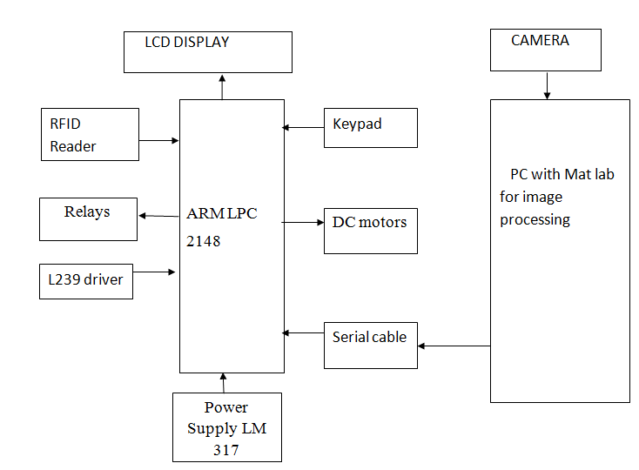
Figure 3. 1: Over All Block Diagram

Working Principal:
Smart ration shop is aimed to develop automated system to distribute the allotted quantity of domestic commodities to the card holders. The developed system works in three phases.
- New user enrollment:
1. The users family is provided with a RFID based ration card.
2. Image templates of all members of the family are collected for identiﬁcation.
- Identiﬁcation of the user:
1. A family member swipes his/her RFID based ration card, the unique ID is matched and the access is granted to proceed further.
2. Image processing identiﬁcation is used to verify the user.
3. Display information about the commodities available for purchase by him/her.
4. Access is granted to the family member to purchase commodities.
- Automatic distribution of commodities:
1. After the family member is granted access, the commodities needed to them will be dispensed.
2. The commodities are distributed by automatic opening and closing of valve.

Matlab and Image Processing
The name MATLAB stands for Matrix Laboratory. MATLAB was written originally to provide easy access to matrix software developed by the LINPACK (linear system package) and EISPACK (Eigen system package) projects. MATLAB is a high performance language for technical computing. It integrates computation, visualization, and programming environment.

Furthermore, MATLAB is a modern programming language environment: it has sophisticated data structures, contains built-in editing and debugging tool and supports object oriented programming. These factors make MATLAB an excellent tool for teaching and research.

MATLAB has many advantages compared to conventional computer languages (e.g., FORTRAN) for solving technical problems. MATLAB is an interactive system whose basic data element is an array that does not require dimensioning. It has powerful built-in routines that enable a very wide variety of computations. It also has easy to use graphics commands that make the visualization of results immediately available. Applications are collected in packages referred to as toolbox. There are tool boxes for signal processing, symbolic computation, control theory, simulation, optimization, and several other of applied science and engineering Image can be assumed as the visualization of what vision senses that is captured by camera. Image is considered as a two dimensional function with variables that represent the spatial coordinate. It holds information about color as well as shapes. In color

Image, RGB color model mixes those three prime color components, red, green and blue, to produce another color. Image capturing and processing have been used widely in diverse applications, such in medical and surveillance applications.

3.1 HARDWARE TOOLS:
3.1.1 Card and reader
User can access the system by bringing a contact less card swiped near the reader. Reader reads the unique 10 digit number from the card and sends it to the controller through the serial port

3.1.2 Identification using Finger print module
A fingerprint module R303a is interfaced with the microcontroller. A predefined algorithm is used to process the fingerprint obtained from the module. Fingerprint processing includes two parts: fingerprint enrollment and fingerprint matching. When enrolling, user needs to enter the finger two times. The system will process the two time finger images, generate a template of the finger based on processing results and store the template.

3.1.3 Microcontroller
An ARM Microcontroller LPC2148 is used. The details of each card holder of the family are enrolled in the database. Microcontroller takes the serial number from reader and access corresponding record in the database in accordance with the thumbprint identification. It has inbuilt power supply which distributes 12 V input into 5 V and 3.3 V regulated output.

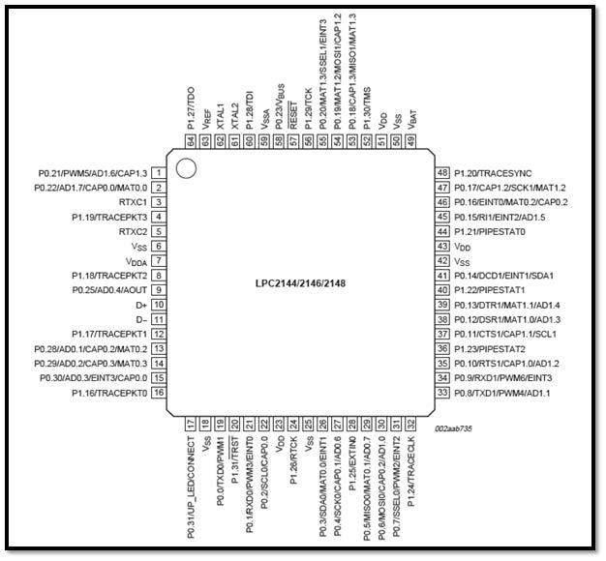
Figure 3.2: pin configuration lpc2148
FEATURES
- 16bit/32-bit ARM7TDMI-S microcontroller in a tiny LQFP64 package.
- 8 kB to 40 kB of on-chip static RAM and 32 kB to 512 kB of on-chip flash memory.128-bit wide interface/accelerator enables high-speed 60 MHz operation.
- In-System Programming/In-Application Programming (ISP/IAP) via on-chip boot loader software. Single flash sector or full chip erase in 400 ms and programming of 256 B in 1 ms.

- Embedded ICE RT and Embedded Trace interfaces offer real-time debugging with the on-chip Real Monitor software and high-speed tracing of instruction execution.
- USB 2.0 Full-speed compliant device controller with 2 kB of endpoint RAM In addition, the LPC2146/48 provides 8 kB of on-chip RAM accessible to USB by DMA.
- One or two (LPC2141/42 vs. LPC2144/46/48) 10-bit ADCs provide a total of 6/14 analog inputs, with conversion times as low as 2.44 s per channel.
- Single 10-bit DAC provides variable analog output (LPC2142/44/46/48 only).
- Two 32-bit timers/external event counters (with four capture and four compare channels each), PWM unit (six outputs) and watchdog.
- Low power Real-Time Clock (RTC) with independent power and 32 kHz clock input

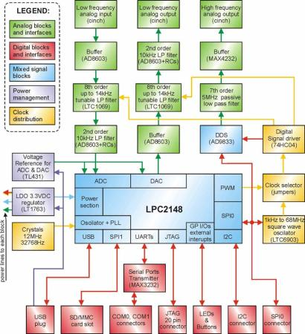

Figure 3. 3 : lpc2148 Block Diagram
The above fig shows the block diagram OF LPC 2148
Peripheral features:
- Two 10 bit A/D converter(AD0 to AD1) provide a total of 14 analog inputs
- Conversion times as low as 244micro second per channel,
- Single 10 bit D/A converter provide variable analog output.

- Two 32 bit timer/external events counter each timer with four. capture and four channels.
- Pwm unit (six outputs).
- Low power real time clock with independent power and dedicate
32 kHz clock bus.
- Two fast 12c bus with 400kbits/sec.
FUNCTIONAL DESCRIPTION OF MICROCONTROLLER BASED ARM LPC2148
The ARM7TDMI-S is a general purpose 32-bit microprocessor, which offers high performance and very low power consumption. The ARM architecture is based on Reduced Instruction Set Computer (RISC) principles, and the instruction set and related decode mechanism are much simpler than those of complex instruction Set Computers (CISC). This simplicity results in a high instruction throughput and impressive real-time interrupt response from a small and cost-effective processor core. Pipeline techniques are employed so that all parts of the processing and memory systems can operate continuously. Typically, while one instruction is being executed, its successor is being decoded, and a third instruction is being fetched from memory.
The ARM7TDMI-S processor also employs a unique architectural strategy known as Thumb, which makes it ideally suited to high-volume applications with memory Restrictions, or applications where code density is an issue. The key idea behind Thumb is that of a super-reduced instruction set. Essentially, the ARM7TDMI-S processor has two instruction sets:
• The standard 32-bit ARM set.
• A 16-bit Thumb set.

The Thumb set’s 16-bit instruction length allows it to approach twice the density of Standard ARM code while retaining most of the ARM’s performance advantage over a traditional 16-bit processor using 16-bit registers. This is possible because Thumb code operates on the same 32-bit register set as ARM code.

Thumb code is able to provide up to 65 % of the code size of ARM, and 160 % of the performance of an equivalent ARM processor connected to a 16-bit memory system. The particular flash implementation in the LPC2141/42/44/46/48 allows for full speed execution also in ARM mode.
It is recommended to program performance critical an short code sections (such as interrupt service routines and DSP algorithms) in ARM mode. The impact on the overall code size will be minimal but the speed can be increased by 30 % over Thumb mode.

On Chip Flash Program Memory
The LPC2141/42/44/46/48 incorporates a 32 kb, 64 kb, 128 kb, 256 kb and 512 kb flash memory system respectively. This memory may be used for both code and data storage. Programming of the flash memory may be accomplished in several ways. It may be programmed In System via the serial port. The application program may also erase and/or program the flash while the application is running, allowing a great degree of flexibility for data storage field firmware upgrades, etc. Due to the architectural solution chosen for an on-chip boot loader, flash memory available for user’s code on LPC2141/42/44/46/48 is 32 kb, 64 kb, 128 kb, 256 kb and 500 kb respectively. The LPC2141/42/44/46/48 flash memory provides a minimum of 100000 erase/write cycles and 20 years of data-retention.

On Chip Static Ram
On-chip static RAM may be used for code and/or data storage. The SRAM may be accessed as 8-bit, 16-bit, and 32-bit. The LPC2141, LPC2142/44 and LPC2146/48 Provide 8 kb, 16 kb and 32 kb of static RAM respectively. In case of LPC2146/48 only, an 8 kb SRAM block intended to be utilized mainly by the USB can also be used as a general purpose RAM for data storage and code storage and execution.

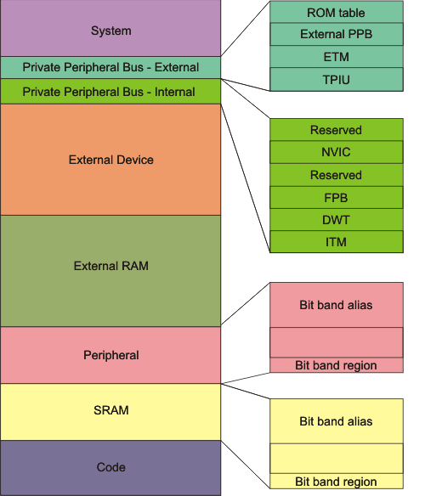
Figure 3.4: Graphical Representation of the ARM Memory
The ARM memory is divided into following regions:
- System - .
- Private Peripheral Bus - External - Provides access to :
- the Trace Port Interface Unit (TPIU),
- the Embedded Trace Microcell (ETM),
- Implementation-specific areas of the PPB memory map.

Private Peripheral Bus - External - Provides access to :
- the Instrumentation Trace Microcell (ITM),
- the Data Watch point and Trace (DWT),
- the Flash patch and Breakpoint (FPB),
The System Control Space (SCS), including the MPU and the Nested Vectored Interrupt Controller (NVIC).

- External Device - This region is used for external device memory.
- External RAM - This region is used for data.
- Peripheral - This region includes bit band and bit band alias areas.
  - Peripheral Bit-band alias - Direct accesses to this memory range behave as peripheral memory accesses, but this region is also bit addressable through bit-band alias.
  - Peripheral bit-band region - Data accesses to this region are remapped to bit band region. A write operation is performed as read-modify-write.
- SRAM - This executable region is for data storage. Code can also be stored here. This region includes bit band and bit band alias areas.
  - SRAM Bit-band alias - Direct accesses to this memory range behave as SRAM memory accesses, but this region is also bit addressable through bit-band alias.
  - SRAM bit-band region - Data accesses to this region are remapped to bit band region. A write operation is performed as read-modify-write.
- Code - This executable region is for program code. Data can also be stored here.

3.1.4 MOTORS AND REALAY CIRCUIT
The motors are used to control the valve arrangement (i.e. to open and close the valve). These motors are controlled by relay (timer) circuit. Relay circuit is used for weight measurement as the grain falls through the funnel and when it reaches the required amount the valve will close automatically.

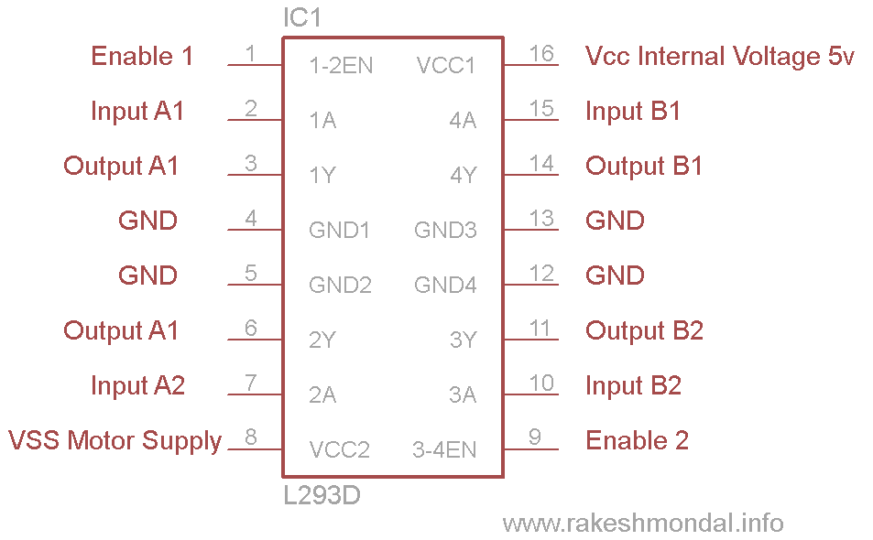
Figure 3.5 Pin Diagram Secrete L239 Driver Motor

Working of L239 driver motor

There are 4 input pins for l293d, pin 2,7 on the left and pin 15 ,10 on the right as shown on the pin diagram. Left input pins will regulate the rotation of motor connected across left side and right input for motor on the right hand side. The motors are rotated on the basis of the inputs provided across the input pins as LOGIC 0 or LOGIC 1.
In simple you need to provide Logic 0 or 1 across the input pins for rotating the motor
LOGIC TABLE
Lets consider a Motor connected on left side output pins (pin 3,6). For rotating the motor in clockwise direction the input pins has to be provided with Logic 1 and Logic0.

• Pin 2 = Logic 1 and Pin 7 = Logic 0 | Clockwise Direction
• Pin 2 = Logic 0 and Pin 7 = Logic 1 | Anticlockwise Direction
• Pin 2 = Logic 0 and Pin 7 = Logic 0 | Idle [No rotation] [Hi-Impedance state]
• Pin 2 = Logic 1 and Pin 7 = Logic 1 | Idle [No rotation]In a very similar way the motor can also operate across input pin 15,10 for motor on the right hand side.

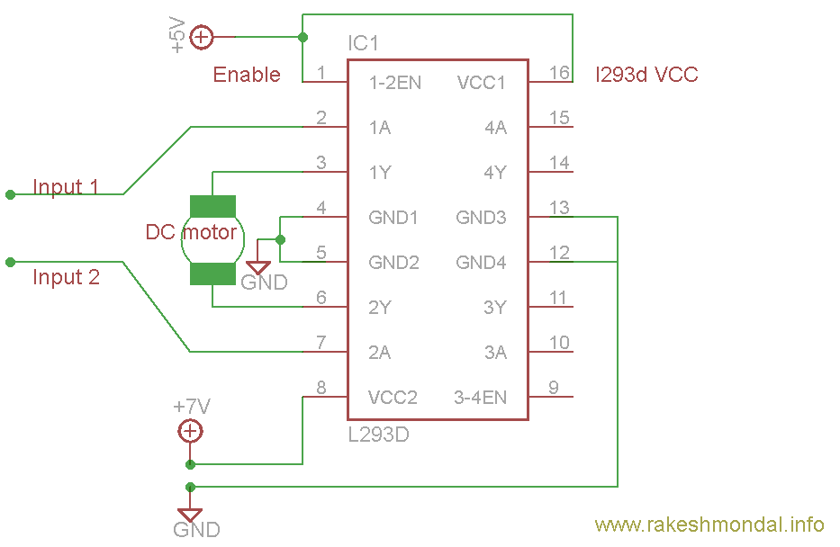Figure 3.6: Circuit Diagram
Voltage specification
VCC is the voltage that it needs for its own internal operation 5v; L293D will not use this voltage for driving the motor. For driving the motors it has a separate provision to provide motor supply VSS (V supply). L293d will use this to drive the motor. It means if you want to operate a motor at 9V then you need to provide a Supply of 9V across VSS Motor supply.

The maximum voltage for VSS motor supply is 36V. It can supply a max current of 600mA per channel. Since it can drive motors Up to 36v hence you can drive pretty big motors with this l293d.VCC pin 16 is the voltage for its own internal Operation. The maximum voltage ranges from 5v and up to 36v.TIP: Don’t Exceed the Vmax Voltage of 36 volts or it will cause damage.

BREAD BOARD USE:

Step 1: Build the motor driver as per usual, and gather your pins.
Step 2: If you have to, snap off two singles from the pin set.
Step 3: Solder the pins into the holes on The bottom of the PCB near the pin
Function labels. You may need to open up the holes bit to make them fit.

Step 4: Insert the driver board into your favorite breadboard. We found having small jumpers to the other side of the bread board makes configuring connections easy.

3.1.5 GSM UNIT
GSM module SIM300 is used to send messages to the card holders after each and every transaction.

3.1.6 HYDRAULIC VALVE
The purpose of flow control in a hydraulic system is to regulate speed. This valve controls the speed of an actuator by regulating the flow rate. The valve is controlled by electric current which passes through a DC motor. The motor operates the hydraulic valve to dispense the oil to the card holder.

3.1.7 LCD AND KEYPAD
The Smart Ration Shop System uses a 16x2 LCD and 4X4 keypad for its operation.

CHAPTER 4
SYSTEM HARDWARE DESCRIPTION

4.1 Radio Frequency Identifier(Rfid) Module

Figure 4.1: RFID reader nsk edk - 125 –TTL
The NSK125 series Radio frequency identification (RFID) Proximity OEM Reader Module has a built-in antenna in minimized form factor. It is designed to work on the industry standard carrier frequency of 125 kHz. A typical RFID reader is shown in figure 4.1. The RFID reader module comes with an internal or an external antenna which facilitates communication with Read-Only transponders of the type UNIQUE or TK5530 via the air interface. The tag data is sent to the host systems via the wired communication interface with a protocol selected from the module both TTL and Wigand Protocol. The RF module is best suited for applications in Access Control, Asset Management, Handheld Readers, Immobilizers, and other RFID enabled applications.

Connection Details
- Connections : 5 volts and GND
- TX: TTL output can be directly connected to microcontroller ( To covert TTL to UART Converter Board is used )
- D0 & D1 : used for wiegand protocol
Features
- Output : TTL or Wigand 26
- Beep indicates tag reading operation
- Compact size and cost-effective

4.2 Microcontroller LPC2148
ARM7 is one of the widely used microcontroller family in embedded system application.ARM is a family of instruction set architectures for computer processors based on a reduced instruction set computing (RISC) architecture developed by British company ARM Holdings. Figure 4.2 shows the arm processor based microcontroller board. A RISC-based computer
Figure 4.2: Arm processor based LPC 2148 Microcontroller

Design approach means ARM processors require significantly fewer transistors than typical processors in average computers. This approach reduces costs, heat and power use. These are desirable traits for light, portable, battery-powered devices including smart phones, laptops, tablet and notepad computers, and other embedded systems.

LPC2148 is the widely used IC from ARM-7 family. It is manufactured by Philips and it is pre-loaded with many inbuilt peripherals making it more efficient and a reliable option for the beginners as well as high end application developer. LPC2148 is having following

Features:
- MCU: LPC2148 16/32 bit ARM7TDMI-S with 512K Bytes Program Flash, 42K Bytes RAM, USB 2.0, RTC, 10 bit ADC 2.44 us, 2x UARTs, 2x 32bit TIMERS, 6x PWM, 1x DAC,WDT, 5V tolerant I/O, up to 60MHz operation standard JTAG connector with ARM 2x10 pin layout for programming/debugging with ARM-JTAG
- USB connector.
- Two channel RS232 interface and drivers
- Two buttons Reset and ISP
- Two status LEDs
- On board voltage regulator 3.3V with up to 800mA current
- Single power supply: 12V AC or DC required
- Power supply LED
- Power supply filtering capacitor
- RESET circuit with external control of Philips ISP utility via RS232
- RESET button
- DBG, BSL slide switch
- 12 MHz crystal on socket
- 32768 Hz crystal and RTC backup battery connector
- Extension headers for all microcontroller ports

4.3 R303a Fingerprint Module
The Figure 4.3 shows a fingerprint module which has been used for enrolment and Authentication purpose.
Figure 4.3: Fingerprint Module
Operation Principle
A fingerprint system has two basic principles :
- It needs to get an image of the finger
- It needs to determine whether the pattern of ridges and valleys in this image matches the pattern of ridges and valleys in pre-scanned images.

The method employed to scan the image is optical scanning. The heart of an optical scanner is a charge coupled device (CCD). A CCD is simply an array of light-sensitive diodes called photo sites, which generate an electrical signal in response to light photons. Each photo site records a pixel, a tiny dot representing the light that hit that spot. Collectively, the light and dark pixels form an image of the scanned scene (a finger, for example).
Typically, an analog to digital converter in the scanner system processes the analog to electrical signal to generate a digital representation of this image. The scanning process starts when a person places the finger on a glass plate, and a CCD camera takes a picture. The scanner has its own light source, typically an array of light-emitting diodes, to illuminate the ridges of the finger.

The CCD system actually generates an inverted image of the finger, with darker areas representing more reacted light (the ridges of the finger) and lighter areas representing less reacted light (the valleys between the ridges). Before comparing the print to stored data, the modules processor makes sure the CCD has captured a clear image.

It checks the average pixel darkness, or the overall values in a small sample, and rejects the scan if the overall image is too dark or too light. If the image is rejected, the scanner adjusts the exposure time to let in more or less light, and then tries the scan again. The fingerprint scanner systems compare specific features of the fingerprint, generally known as minutiae. To get a match, the scanner system doesn't have to end the entire pattern of minutiae both in the sample and in the print on record; it simply has to end a sufficient number of minutiae patterns that the two prints have in common. The exact number varies according to the scanner programming.

Hardware Connection
The module may communicate with MCU of 3.3V or 5V power via serial interface: TD (pin2 of P1) connects with RXD (receiving pin of MCU), RD (pin 3 of P1) connects with TXD (transferring pin of MCU). The computer (PC) should be in RS-232 mode, level converting circuit, like MAX232, between the Module and PC is added. The default baud rate is 57600bps. User may set the baud rate in 9600-115200bps.

4.4 Global Systems for mobile communications (GSM) Modem Module

GSM Modem-RS232 is built with Dual Band GSM engine- SIM300, works on frequencies 900/1800 MHz The Modem comes with RS232 interface, which allows connecting PC as well as microcontroller with RS232 Chip (MAX232). The baud rate is configurable from 9600-115200 through AT command. It is suitable for SMS, Voice as well as DATA transfer application in M2M interface. The onboard Regulated Power supply allows connecting wide range of unregulated power supply. Using this modem, audio calls can be made, SMS can be sent/read, incoming calls can be attended and internet can be accessed through simple AT commands. Figure 4.4 shows a GSM modem SIM 300.

Figure 4.4: GSM modem SIM 300
GSM Modem Features

- Dual-Band GSM 900/1800 MHz
- RS232 interface for direct communication with computer or MCU kit
- Configurable baud rate
- Wire Antenna ( SMA connector with GSM Antenna Optional )
- SIM Card holder.
- Built in Network Status LED
- Inbuilt Powerful TCP/IP protocol stack for internet data transfer over GPRS.
- Normal operation temperature: -20 C to +55 C
- Input Voltage: 12V DC

4.5 DC Motor
Three DC motor system is used to open and close the valves for automatic distribution of rice, sugar and oil. The initial valve arrangement is made to prevent fall of grains and oil. The three DC motors, each having specifications 12 V, 60 RPM and 0.37 A are used for this purpose. DC motor used in the system is shown in Figure 4.5.

Figure 4.5: DC Motor

COMPOSITION OF DC MOTOR
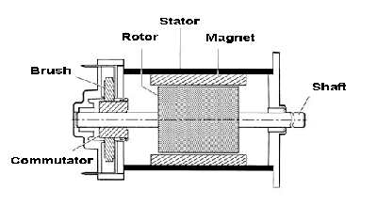
Figure 4.6 Composition of DC Motor

The stator is formed by a metal carcass and one or more magnets that create a permanent magnetic field inside the stator. At the rear of the stator are the brush mountings and the brush gear which provide electrical contact with the rotor. The rotor is itself formed by a metal carcass carrying coils which are interconnected at the commutate at the rear of the rotor The commentator and brush assembly then select the coil through which the electric current passes in the opposite direction.

Principle of operation
Whatever the complexity of the rotor coil windings, once they are energized, they may be represented in the form of a ferromagnetic cylinder with a solenoid wrapped around it. The wire of the solenoid is in practice the wire bundle located in each groove of the rotor. The rotor, when energized, then acts as an electromagnet, the magnetic field following the axis separating the wires of the solenoid in the direction of the current which flows through them.

4.6 Hydraulic valve
The purpose of flow control in a hydraulic system is to regulate speed. These valves control the speed of an actuator by regulating the flow rate. The valve is controlled by electric current passed through the DC motor.

Here it is used to dispense the oil to the card holder. A switch has to be pressed using DC motor arrangement to collect the liquid. Their tasks are to shut off, release, dose, distribute or mix fluids. Figure 4.6 shows the cross sectional view of Hydraulic valve.
Figure 4.6: Hydraulic Valve

4.7 Relay Circuit
Relays are simple switches which are operated both electrically and mechanically. Relays consist of an electromagnet and also a set of contacts. The switching mechanism is carried out with the help of the electromagnet. Intially the contact is made with normally closed (NC) pin and when the current is passed the contact is made with normally open (NO) pin for a specified delay. Figure 4.7 shows a typical relay which operates on 12V.

Figure 4.7: Relay Circuit

4.8 LCD and Keypad
The system incorporates a 16X2 LCD and a 4*4 keypad. A keypad is a set of buttons arranged in a block or "pad" which usually bear digits, symbols and usually a complete set of alphabetical letters. If it mostly contains numbers then it can also be called a numeric keypad.

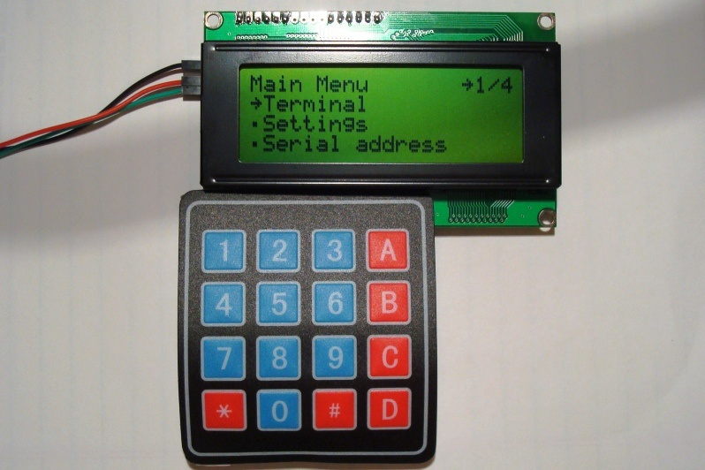
Figure: 4.8 LCD with Keypad

CHAPTER 5
SYSTEM SOFTWARE

The software’s used for the development of the system are
- Kiel Vision 4
- Philips LPC2000 ash utility V2.2.3

5.1 Kiel vision 4
The Vision from Kiel combines project management, make facilities, source coding editing, program debugging and complete simulation in one powerful environment. The Vision development platform is easy to use and helping one quickly create embedded program that work. The vision editor and debugger are integrated in a single application that provides a seamless embedded project development environment.

5.2 Philips LPC2000 ash utility V2.2.3
Philips LPC2000 ash utility is a special software program from Phillips which is used to send new firmware to the product. It is used to serially dump the code. Without the Boot loader, updating the main firmware in the product is more difficult, because the enclosure must be opened to access the configuration button. The Phillips program, simplifies the firmware update process. Figure 5.1 shows LPC2000 ash utility window which is used for serial dumping of the code.
Figure 5.1: LPC2000 Flash Utility Window

CHPTER 6
SYSTEM IMPLEMENTATION
6.1 Project Program Module

Figure 6.1: Block diagram of RFID and thumbprint Identification based smart ration
Shop

Following components are used to achieve desired functionality.
6.1.1 Card and Reader
User can access the system by bringing a contact less card swiped near the reader. Reader reads the unique 10 digit number from the card and sends it to the controller through the serial port.

6.1.2 Identification using Finger print module
A fingerprint module R303a is interfaced with the microcontroller. A predefined algorithm is used to process the fingerprint obtained from the module. Fingerprint processing includes two parts: fingerprint enrolment and fingerprint matching. When enrolling, user needs to enter the finger two times. The system will process the two time finger images, generate a template of the finger based on processing results and store the template.

6.1.3 Microcontroller
An ARM Microcontroller LPC2148 is used. The details of each card holder of the family are enrolled in the database. Microcontroller takes the serial number from reader and access corresponding record in the database in accordance with the thumbprint identification. It has inbuilt power supply which distributes 12 V input into 5 V and 3.3 V regulated output.

6.1.4 Motors and Relay circuit
The motors are used to control the valve arrangement (i.e. to open and close the valve). These motors are controlled by relay (timer) circuit. Relay circuit is used for weight measurement as the grain falls through the funnel and when it reaches the required amount the valve will close automatically.

6.1.5 GSM Unit
GSM module SIM300 is used to send messages to the card holders after each and every transaction.

6.1.6 Hydraulic Valve
The purpose of flow control in a hydraulic system is to regulate speed. This valve controls the speed of an actuator by regulating the flow rate. The valve is controlled by electric current which passes through a DC motor. The motor operates the hydraulic valve to dispense the oil to the card holder.

6.1.7 LCD and Keypad
The Smart Ration Shop System uses a 16x2 LCD and 4X4 keypad for its operation.

6.1.8 RFID Module
RFID works in serial communication. Universal asynchronous receiver transmitter (UART0) of the Arm board is used for RFID. TX pin of the RFID is connected to RX pin of the microcontroller. Figure 6.2 demonstrates the flow diagram of RFID.

Figure 6.2: Flowchart Illustrating the Working of RFID

6.1.9 Fingerprint Module

The R303a module uses its TX and RX pin to connect with the TX and RX pin of the Arm controller. It works under serial communication using UART1 of the arm controller. The module initially waits for the Arm commands. After receiving those commands the module sends its 15 byte character response back to Arm controller. The controller monitors the 9th byte for matching purpose. If the byte is matched the user is authenticated. Figure 5.3 illustrates the working flow of fingerprint module.
Figure 6.3: Flowchart Illustrating the Working of Fingerprint Module

6.1.10 Flow Chart of the System
GSM modem communicates serially with the arm controller using UART0. The TX and RX pins of the GSM module is connected to the TX and RX pin of the arm controller. Initially UARTs are initialized followed by GSM. The arm controller compares the unique tag ID with the data base. Once the user is authenticated he/she is asked to scan his/her finger as shown in Fig 6.4.

Figure 6.5 demonstrates the working procedure after successful authentication and selection of a particular family where user is asked to select the product with valid quantity followed by automatic dispensing of commodities which is terminated by electronic bill sent in the form of message and the database is maintained.

Figure 6.4: Flowchart of the System upto Authentication Process

Figure 6.5: Flowchart of the System After Successful Authentication

CHAPTER 7
RESULT
This section illustrates the result and snapshot of overall project

7.1 Snapshot
The RFID, Finger print identification and GSM module are interfaced to the ARM LPC2148 microcontroller through serial port. The software implementation was done using Kiel Vision 4 and Philips LPC2000 ash utility V2.2.3. The user swipes the RFID card and a unique 10 character ID is received in microcontroller.

This is used to classify a user in his/her family. It is followed by Finger print identification to verify the identity of the user. After the RFID card is swiped, the user is authenticated but further the user is asked to scan his/her finger print which acts as a level 2 authentication to stop any fraudulent activity in case if the RFID card is stolen. Figure 6.1 shows the working of overall system. Each family is provided with a RFID card and family members enroll their fingerprint. 3 templates of finger prints are stored per family. Once the member is authenticated by his/her fingerprint he/she is asked to select the commodities among rice, sugar and oil. Once the product is selected he/she is asked to enter the quantity in kgs in case of grains and in liters in case of oil. Once the desired quantity of ration is entered, the motor will automatically disburse the grains. The DC motor is automatically controlled by the microcontroller via relays enabling automatic disbursing of commodities. The Figure 6.2 shows that the user is intimated by two SMSs,one after scanning the _nger and another after completing transaction which will also act as an electronic bill and database will be updated after every transaction.

Figure 7.1: illustrate the Working of Overall System

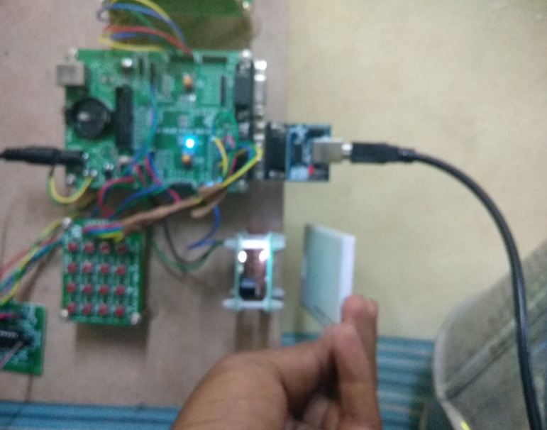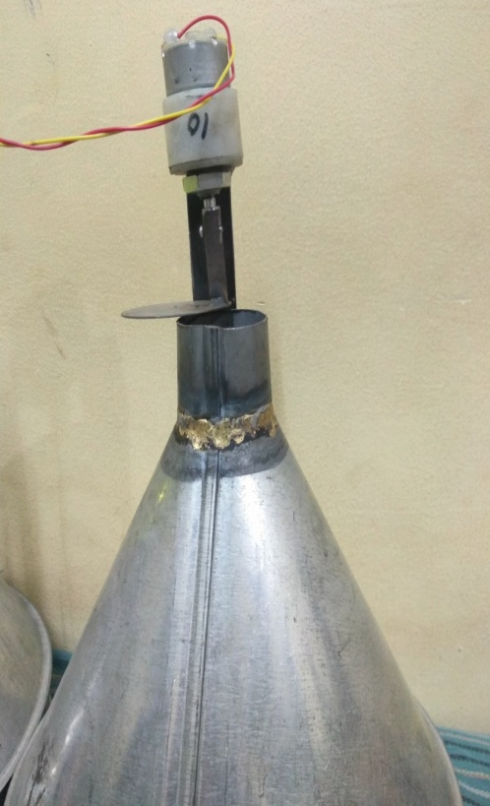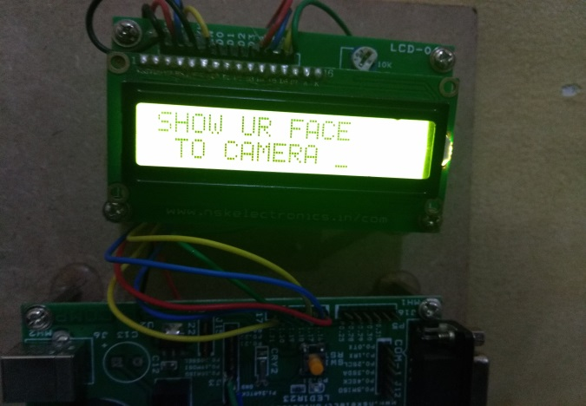

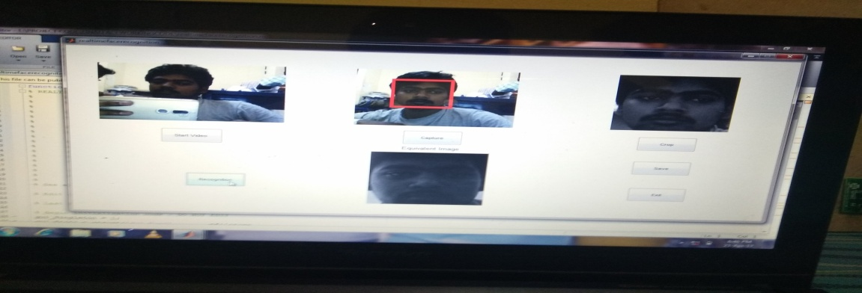

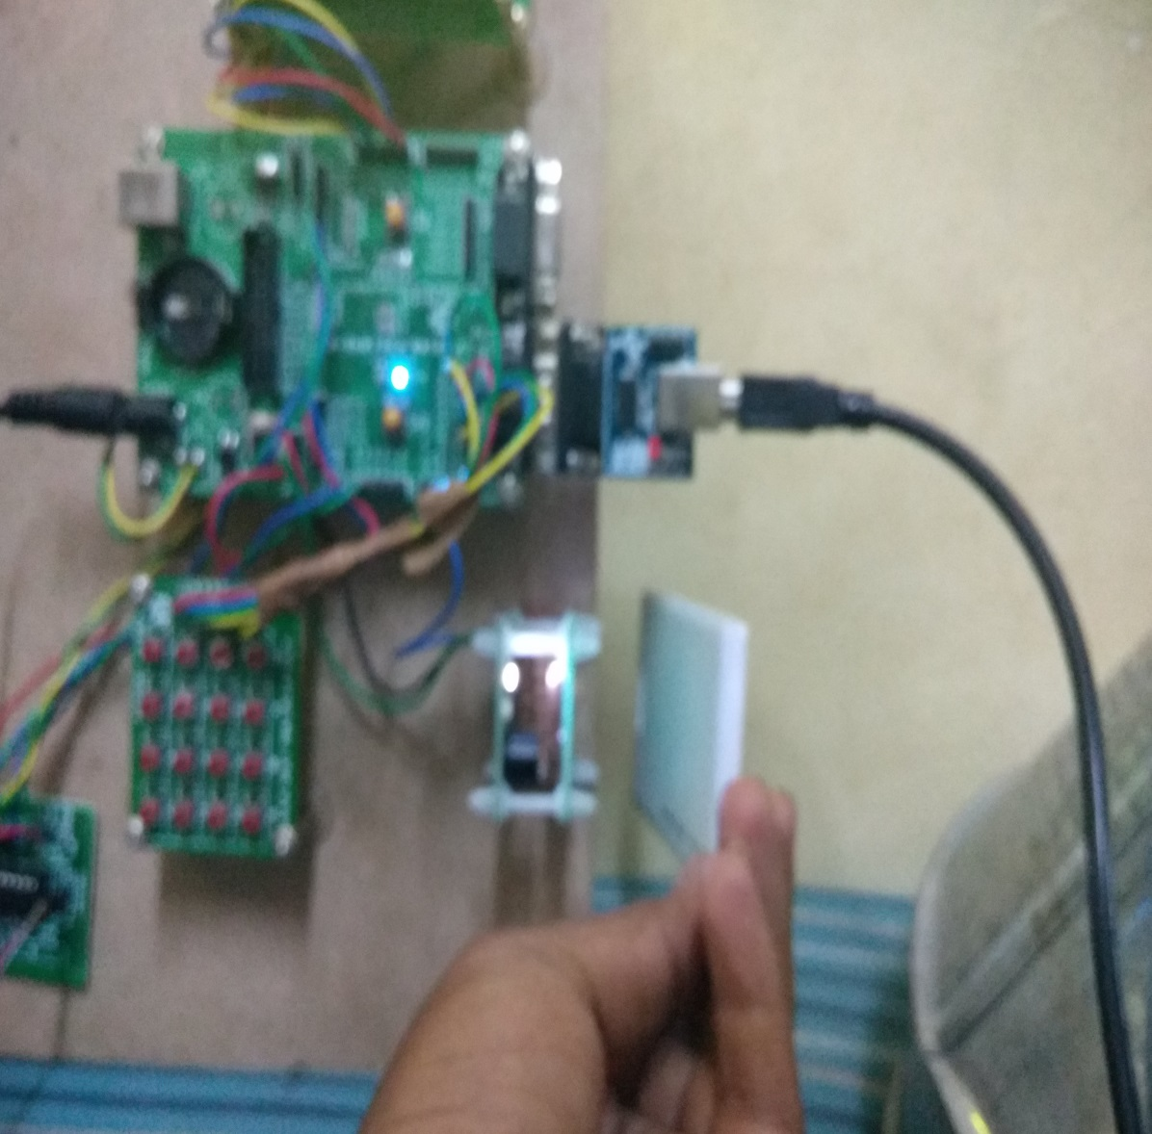

Figure 7.2: Snapshot for Overall Project

When the person comes to the ration shop he is showing his face to camera due to inbuilt in MAT lab instruction LCD display will displays show ur face to camera it displayed on the lcd display.
After showing face to camera the mat lab instruction will compare the captured image and data base image if both compared images are equivalent then the system will execute the further process.
After recognizing the face the LCD will displays the command please swipe your card. Then the person should swipes the card by Using RFID card reader.

7.2 Quantity Analysis
The quantity analysis of different commodities is tabulated as shown in Fig 6.4. The error in weight for rice is 30-40 grams and sugar is around 25-35 grams. In case of oil the measurement error is around 10 ml.

Commodities | Actual quantity | Measured quantity | Error
Rice(in kgs) | 1kg | 0.970kg | 30gm
 | 1kg | 0.960kg | 40gm
Sugar(in kgs) | 1kg | 0.975kg | 25gm
 | 1kg | 0.965kg | 35gm
Oil(in mltrs) | 100ml | 90ml | 10ml

Table 7.1 Analysis of Quantity

CHAPTER 8
ADVANTAGES
1) Economical
2) Portable
3) Low maintenance cost
4) Forgeries can be prevented
5) It dispenses the commodities automatically
6) The system can be made open all the time since it is autonomous
7) Goods will be weighed accurately since the system is automatic

CHAPTER 9
APPLICATIONS
- It can be used in Fuel supply system in underground tunnels.
- The concept can be used in electricity management system.
- The concept can be used in Home appliance control.
- The concept can be used in Health care sector.
- The concept can be used in Making of smart cities.

CHAPTER 10
CONCLUSION

The Smart Ration Shop is an Automation of the Public Distribution System (PDS) and its recompense over the present Fair Price Shops. By means of this Performance we can reduce the corruption level. The two levels of authentication first by RFID and further by Fingerprint makes the system more secure, eliminates fake ration card holders and protects the interest of the common people ensuring the country's food security. It gives an answer to the common people who stand in ration shop in queues for hours to purchase their essential Supplies by automatic distribution of commodities. It will help the country's economy to Reach new heights. The automated PDS is easy to implement and requires much less hard work when com- Pared to the other system. Using this system malpractices can be avoided because there is no manual operations and also all information is stored in a database. So this system will Be really helpful to the people below poverty line.

CHAPTER 11

FUTURE ENHANCEMENT
The number of grocery items to be dispensed can be increased. Speed of motor can Be controlled by driver using high performance microcontrollers. Dispensing of oil can be fastened using high capacity hydraulic valve.

REFERENCES

- Jain, L.C. et al. (Eds.). 1999. Intelligent Biometric Techniques in Fingerprint and Face Recognition. Boca Raton, FL: CRC Press.
- M. Govarthan. People stand in long queues to get kerosene at ration shops.
- http://www.hindu.com/20008/01/15/stories/2008011550460300.htm, 2008[Online; accessed 14-November-2014].
- Roy Want. An introduction to rﬁd technology. IEEE CS and IEEE comSoc, 5(1):25-33,2006.
- ARM Cortex-M3; 1st Edition; Vincent Mahout; Wiley-ISTE; 256 pages; 2012.
- UM10139 LPC214x User manual - NXP Semiconductors
- Mazumdar, Subhra; Dhulipala, Venkata (2008). ”Biometric Security Using Finger Print Recognition”

